**HTML | <ins> cite Attribute**

Last Updated : 04 Jul, 2022

The **HTML <ins> cite Attribute**is used to specify *the URL of the document or message which denotes the reason of deleting the text*.   
**Syntax:**

<ins cite="URL">

**Attribute Values:**

* **URL:** It specifies the URL of the document that defines why the text was inserted

**Possible values are:**

* **Absolute URL:** It is used to point out other websites (like cite =”http://www.w3schools.com”)
* **Relative URL:** It is used to point out the page within the website. (like cite=”geeks.htm”).

**Example:** 

* html

|  |
| --- |
| <!DOCTYPE html>  <html>    <head>      <title>        HTML |        <ins> cite Attribute    </title>      <style>          del {              color: red;          }            ins {              color: green;          }            h1 {              color: green;          }            body {              text-align: center;          }      </style>  </head>    <body>      <h1>GeeksforGeeks</h1>      <h2>HTML | <ins> cite Attribute</h2>        <p>GeeksforGeeks is a          <del>mathematical</del>            <!-- Assigning id to 'ins' tag -->          <ins id="GFG" cite="ide.GeeeksForGeeks.com">              computer          </ins>science portal</p>      </body>    </html> |

**Output :** 

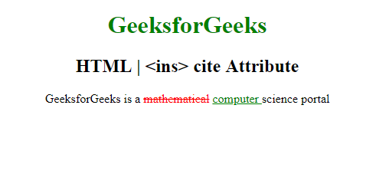

**Supported Browsers:** The browser supported by **HTML <ins>cite Attribute** are listed below: 

* Google Chrome
* Internet Explorer
* Firefox
* Opera
* Safari

Dive deep into the world of JavaScript with our [JavaScript Full Course Online](https://www.geeksforgeeks.org/courses/javascript?utm_campaign=three_90_345_abt&utm_medium=gfgcontent_abt&utm_source=geeksforgeeks), offering everything from the basics to advanced techniques. Learn how to build interactive websites, optimize your code, and earn a certification to showcase your skills.